End-to-End MLOps Demo

What You Will Learn
In this notebook, we will follow a simple MLOps workflow:
1 Raw Data
2 │
3 ▼
4 Data Transformation
5 │
6 ▼
7 Model Training
8 │
9 ▼
10 Model Versioning
11 │
12 ▼
13 Model Registry
14 │
15 ▼
16 Inference (Prediction)
By the end, you will understand:
- How data is loaded
- How features are created
- How a machine learning model is trained
- How models are versioned (v1, v2, ...)
- How a model registry works
- How predictions are made on new data

Folder Structure
Create the following folders and files:
1 MLOps_Demo
2 │
3 ├── data
4 │ customer_data.csv
5 │
6 ├── models
7 │
8 ├── registry
9 │
10 └── MLOps_Demo.ipynb

What each folder does
Folder | Purpose
data | Stores raw input data
models | Stores trained model files
registry | Stores model tracking information
notebook | Where all MLOps steps are executed

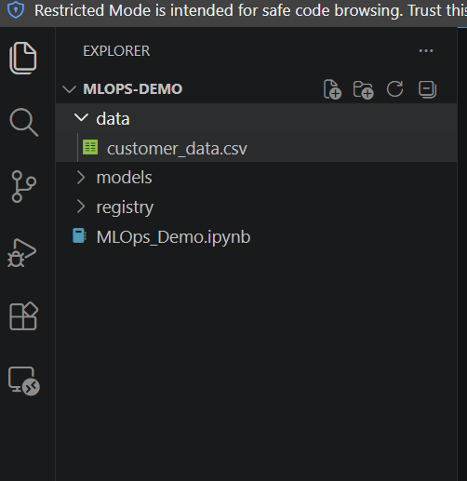

Cell 1 - Import Required Libraries

Purpose
Import the Python libraries needed for the demo.
import pandas as pd
import joblib
from pathlib import Path

from sklearn.tree import DecisionTreeClassifier

Explanation
- pandas → works with tabular data
- joblib → saves and loads ML models
- Path → creates folders and file paths
- DecisionTreeClassifier → machine learning algorithm

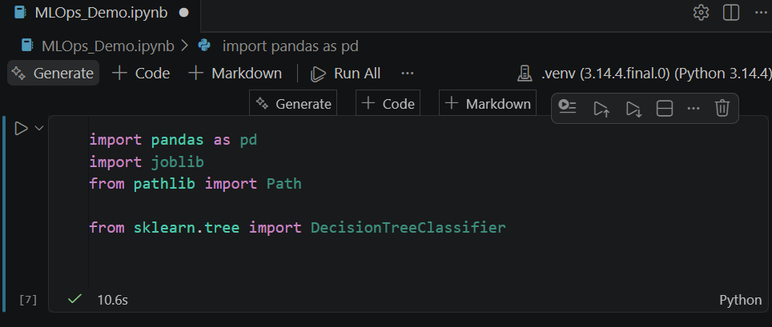

Cell 2 - Load Raw Data

Purpose
Read customer data from a CSV file.
df = pd.read_csv("data/customer_data.csv")
print(df.head())

Example Data
1 CustomerID DataGB Calls Bill
2 1001 10 120 800
3 1002 15 150 950
4 1003 5 80 500

Explanation
At this stage we are simply loading the raw business data.
Think of this as:
"This is the information coming from the source system."

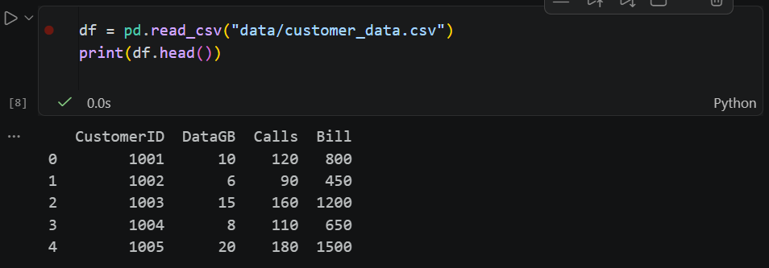

Cell 3 - Data Transformation (Feature Engineering)

Purpose
Convert raw data into ML features.
# =====================================================
# STEP 3 - Transform Raw Data into Features
# =====================================================

print("Generating AI Features...")

# Feature 1
# Copy monthly internet usage
df["MonthlyDataUsage"] = df["DataGB"]

# Feature 2
# Copy average number of calls
df["AverageCallCount"] = df["Calls"]

# Feature 3
# Copy monthly bill
df["MonthlyBill"] = df["Bill"]

# Feature 4
# Calculate Data Usage / Bill Ratio
df["UsageBillingRatio"] = df["DataGB"] / df["Bill"]

print("✅ Feature Engineering Completed")

display(df)

What is happening?
We create new columns that the model can learn from.

Example
Before:
1 DataGB Calls Bill
2 10 120 800
After:
1 MonthlyDataUsage
2 AverageCallCount
3 MonthlyBill
4 UsageBillingRatio

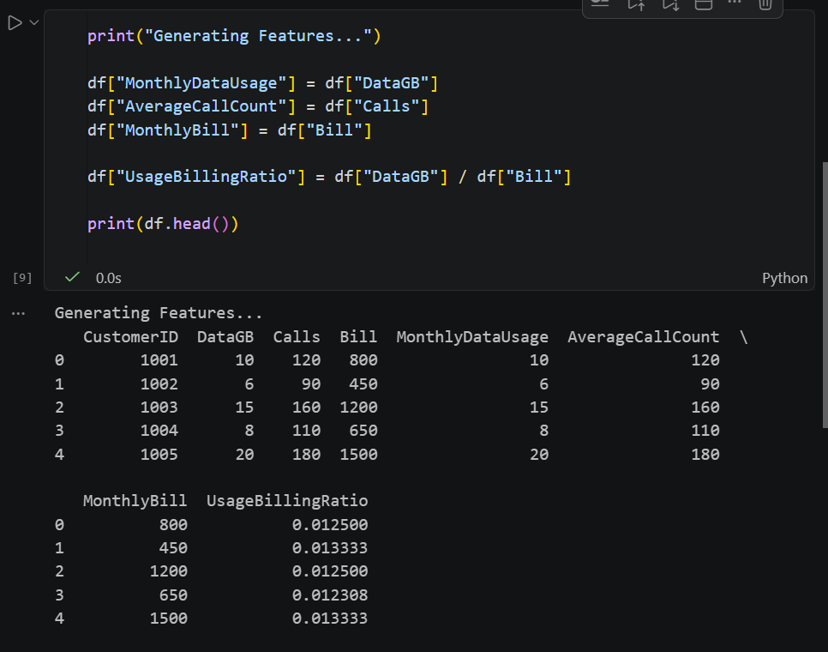

Key Learning
✅ Raw Data → Features
This is called Feature Engineering.

Cell 4 - Train the Machine Learning Model

Purpose
Train a model using the generated features.
# -------------------------------------------------------
# STEP 4 - Train the AI Model
# -------------------------------------------------------

# Create a new column called BillingStatus.
# This is the target (label) that the AI model will learn to predict.
# 0 = Normal Billing
# 1 = Billing Anomaly

df["BillingStatus"] = [0, 0, 1, 0, 1, 0, 0, 1, 0, 1]

# -------------------------------------------------------
# Select the input features for training
# -------------------------------------------------------

# X contains the independent variables (features)
# that will be used to train the AI model.

X = df[
[
"MonthlyDataUsage", # Monthly internet usage (GB)
"AverageCallCount", # Number of calls made
"MonthlyBill", # Monthly bill amount
"UsageBillingRatio" # Data Usage ÷ Monthly Bill
]
]

# -------------------------------------------------------
# Select the target column
# -------------------------------------------------------

# y contains the expected output (target)
# that the model should learn.

y = df["BillingStatus"]

# -------------------------------------------------------
# Create the Machine Learning Model
# -------------------------------------------------------

# Create a Decision Tree Classification model.

model = DecisionTreeClassifier()

# -------------------------------------------------------
# Train the AI Model
# -------------------------------------------------------

# Train the model using the selected features (X)
# and the target values (y).

model.fit(X, y)

# -------------------------------------------------------
# Display Success Message
# -------------------------------------------------------

print("✅ AI Model Trained Successfully")

Explanation
The model learns patterns from historical data.
Target values:
1 0 = Normal Customer
2 1 = Premium Customer

Key Learning
✅ Features + Labels → Trained Model

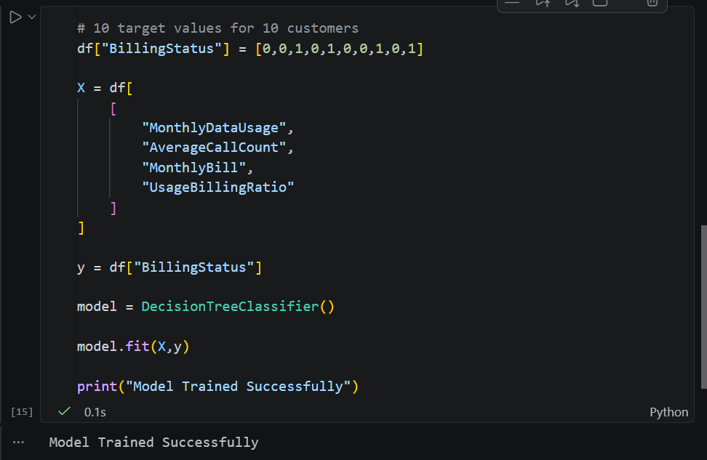

Cell 5 - Model Versioning

Purpose
Save the trained model as Version 1.
# Assign model version
version = "v1"
# Create models folder if it does not exist
model_folder = Path("models")
model_folder.mkdir(exist_ok=True)
# Save trained model
joblib.dump(
model,
model_folder / f"billing_model_{version}.pkl"
)
print("Model Saved")
print("Version:", version)

Output
1 Model Saved
2 Version: v1

Folder Contents
1 models
2 │
3 └── billing_model_v1.pkl

Key Learning
Every trained model gets a unique version.
Examples:
1 v1
2 v2
3 v3
This helps track changes over time.

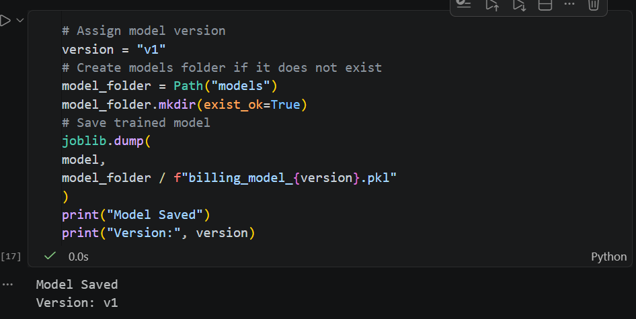

Cell 6 - Create a Simple Model Registry

Purpose
Track model information.
# Create a simple model registry
registry = pd.DataFrame(
{
"Model Version": ["v1"],
"Accuracy": [94],
"Status": ["Production"]
}
)
# Save registry
registry.to_csv(
"registry/model_registry.csv",
index=False
)
print(registry)

Output
1 Model Version Accuracy Status
2 v1 94 Production

Explanation
This CSV acts as a very simple Model Registry.
In enterprise projects this is usually:
- MLflow
- Azure ML Registry
- Databricks Model Registry
For learning purposes, a CSV file is easier to understand.
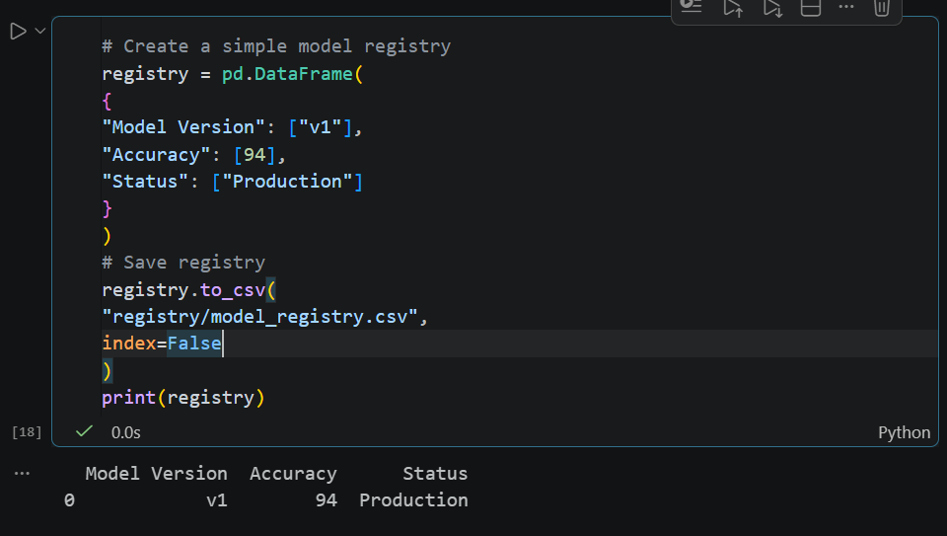

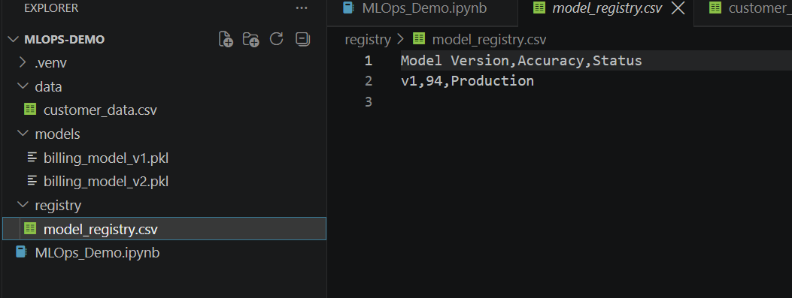

Cell 7 - Inference (Make Predictions)

Purpose
Use the saved model to predict on new data.
# Load saved model
loaded_model = joblib.load(
"models/billing_model_v1.pkl"
)

# New customer data
new_customer = pd.DataFrame(
{
"MonthlyDataUsage": [12],
"AverageCallCount": [130],
"MonthlyBill": [900],
"UsageBillingRatio": [0.013]
}
)

# Predict customer category
prediction = loaded_model.predict(new_customer)
print(prediction)

Example Output
1 [0]

Meaning
1 1 = Premium Customer
or
1 0 = Normal Customer

Key Learning
✅ Saved Model → Real-World Prediction

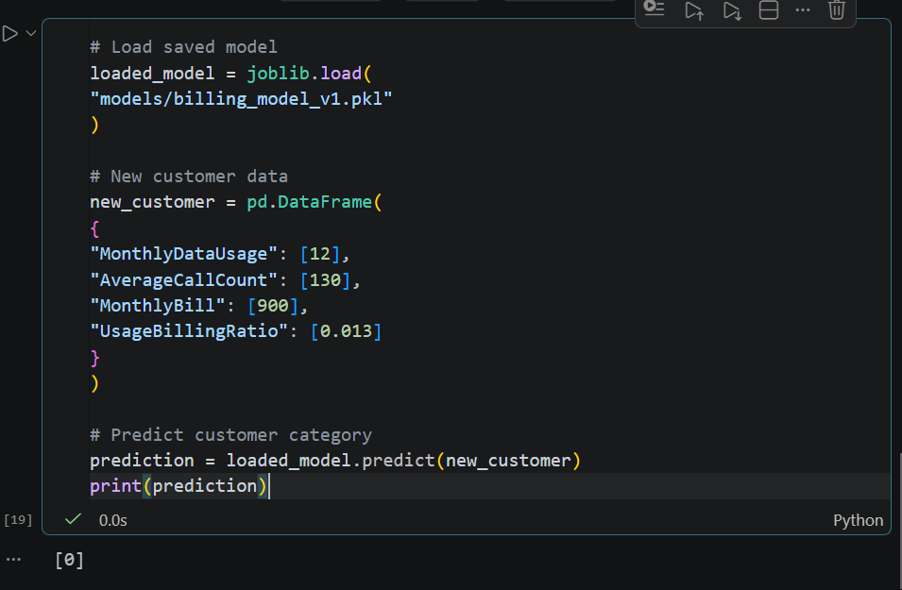

Cell 8 - Create a New Version of the Model

Purpose
Simulate a new training cycle.

Step 1
Modify: customer_data.csv

Change Value of any cell

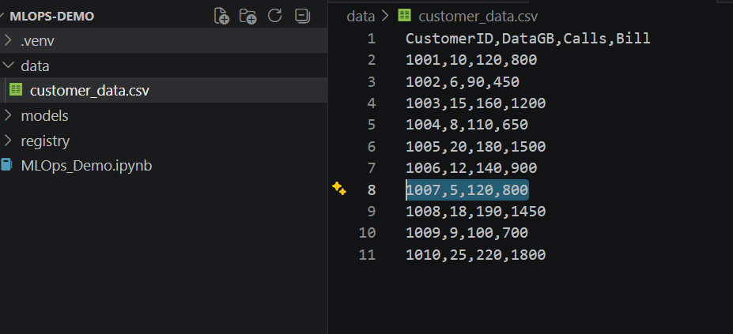

Step 2
Run again:
Cell 2

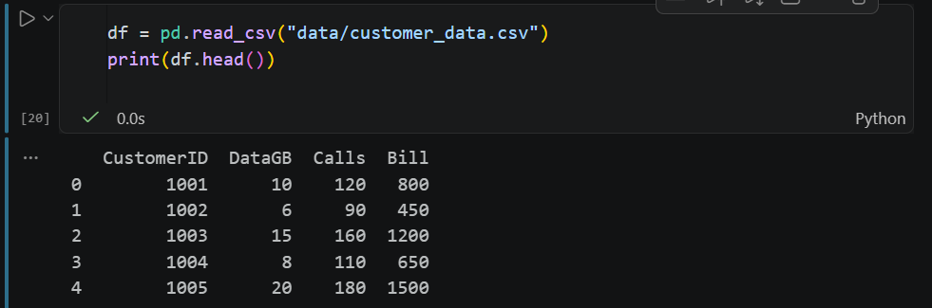

Cell 3

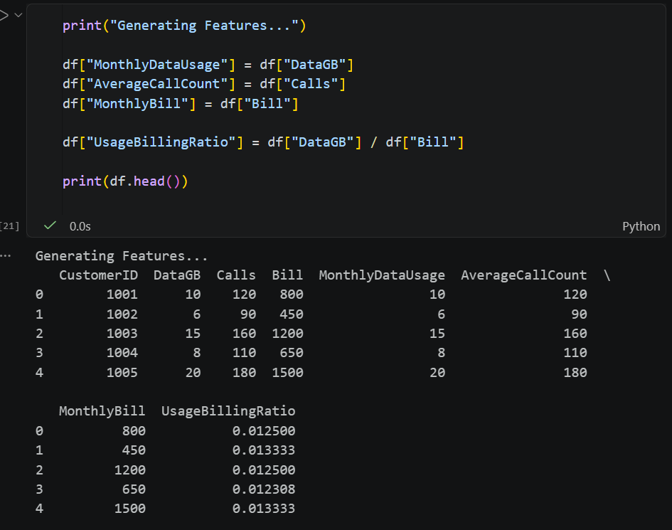

Cell 4
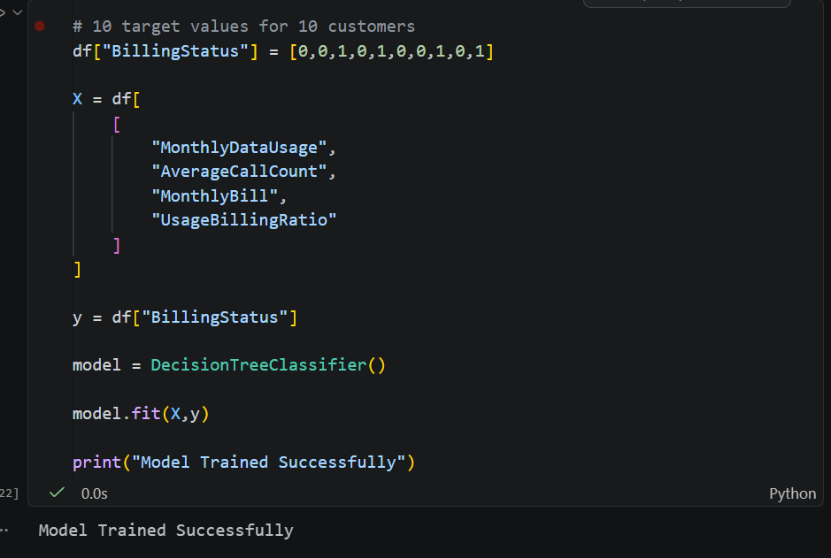

Step 3
Change:
1 version = "v2"

Step 4
Run Cell 5 again.

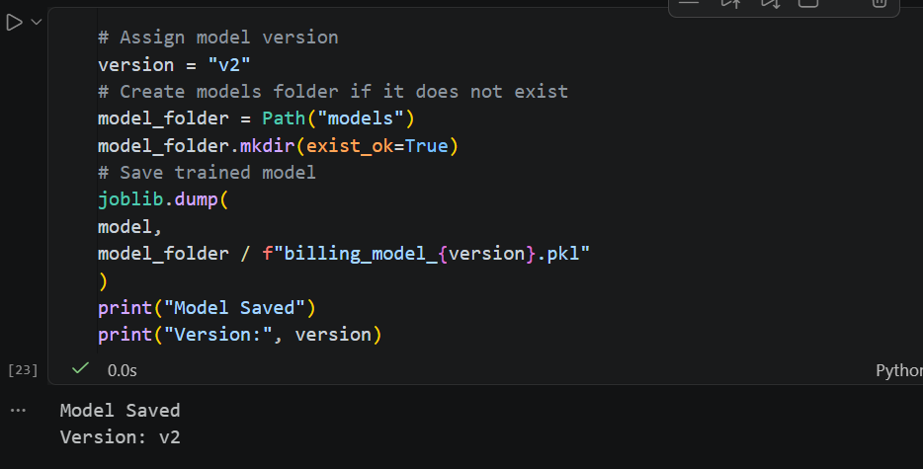

Result
1 models
2 │
3 ├── billing_model_v1.pkl
4 │
5 └── billing_model_v2.pkl

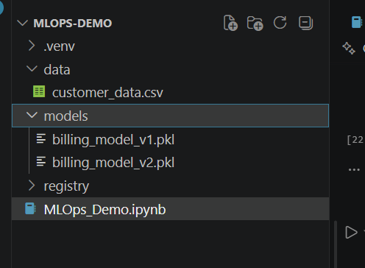

Key Learning
Every retraining creates a new model version.

Cell 9 - Update the Model Registry

Purpose
Track multiple model versions.
# Update registry with latest versions
registry = pd.DataFrame(
{
"Model Version": ["v1", "v2"],
"Accuracy": [94, 96],
"Status": ["Archived", "Production"]
}
)

registry.to_csv(
"registry/model_registry.csv",
index=False
)

print(registry)

Output
1 Model Version Accuracy Status
2 v1 94 Archived
3 v2 96 Production

Explanation
Here:
- v1 is the old model
- v2 is the current production model
This is exactly how organizations manage model releases.
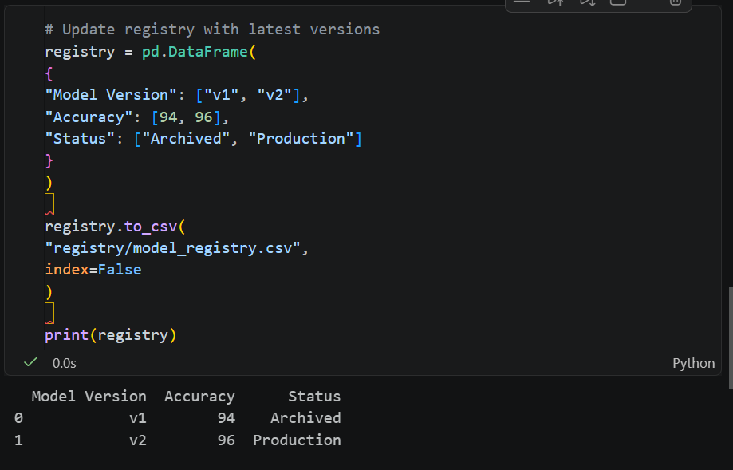

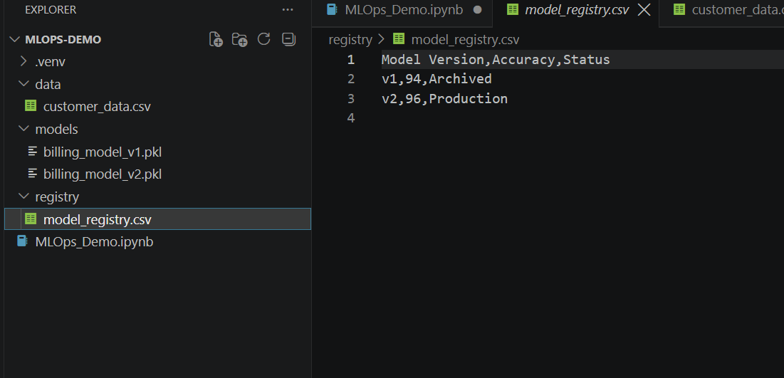

Inference with New Model

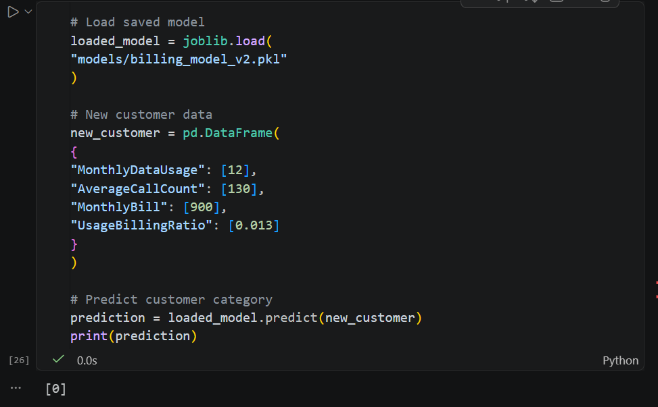

Final MLOps Flow
1 customer_data.csv
2 │
3 ▼
4 Data Transformation
5 │
6 ▼
7 Feature Dataset
8 │
9 ▼
10 Model Training
11 │
12 ▼
13 billing_model_v1.pkl
14 │
15 ▼
16 Model Registry
17 │
18 ▼
19 billing_model_v2.pkl
20 │
21 ▼
22 Inference

Why This Approach Is Great for Beginners
For a 2-hour instructor-led MLOps workshop, students can physically see every artifact created during the process.
MLOps Concept | What Students Can See
Raw Data | customer_data.csv
Feature Engineering | New columns in DataFrame
Model Training | model.fit()
Model Versioning | billing_model_v1.pkl, billing_model_v2.pkl
Model Registry | model_registry.csv
Inference | Predictions on new customer data

Final Takeaway
This notebook teaches the core MLOps mindset:
Data → Features → Model → Versioning → Registry → Prediction
Once students understand this workflow, they can easily transition to enterprise tools like MLflow, Azure Machine Learning, Databricks, Kubeflow, or SageMaker because the concepts remain exactly the same.

